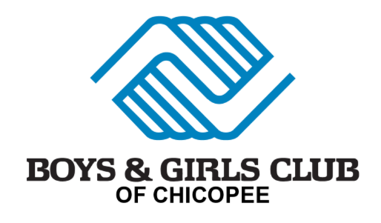
13th Annual
“Black Tie & Sneakers” Gala!

Sponsorship Opportunities

Join us with support for an evening of food, entertainment, raffle and live auction as we celebrate the
mission of the Boys & Girls Club of Chicopee!
Friday – November 1, 2024
5:30- 6:30pm Cocktail Hour until 11:00pm at the Log Cabin in Holyoke, MA
The evening will include dinner, live music by Ready Set Go, photo booth, live auction, and a focus on the impact of the Boys & Girls Club of Chicopee. Anticipated attendance is 300 people.

Presenting Sponsor $5,000
· Logo prominently displayed at the event and during the presentation
· Name/logo prominently displayed in all printed materials (invitations, flyers, press releases, etc.)
· Name/logo & link displayed on our website
· Full page (8” tall x 4.5” wide) color ad inside the front cover of the digital program booklet
Logo prominently displayed in event 3-fold brochure
· 3 tables of 8 at the event ($1,200 value)

Platinum Sponsor $2,500
· Logo displayed at the event and during the presentation
· Name/logo & link displayed on our website
· Full page (8” tall x 4.5” wide) color ad in the digital program booklet
Logo in event 3-fold brochure
· 2 tables of 8 at the event ($960 value)

Gold Sponsor $1,000
· Logo displayed at the event and during the presentation
· Full page (8” tall x 4.5” wide) color ad in the digital program booklet
Logo in event 3-fold brochure
· 1 table of 8 at the event ($480 value)

Silver Sponsor $500
· Name displayed at the event
· Half page (3.75” tall x 4.5” wide) color ad in the digital program booklet
Logo in event 3-fold brochure
· 4 tickets to the event ($240 value)

Bronze Sponsor $250
· Business card (2.5” tall x 3” wide) color ad in the digital program booklet
Listed in event 3-fold brochure
· 2 tickets to the event ($120 value)
Company name as it should appear in print:__________________________________________________________
Address:________________________________________City:______________________State:_____Zip:_______
Contact Name:____________________________Phone:(___)___________Email:___________________________
Sponsorship Level:_____________________Contribution:$_____________Check Enclosed CC Invoice
Credit Card:_______________________________________________Expiration:_____________CVC:_________
Signature:__________________________________________________________Date:______________________
Please email all artwork (JPEG) to Lynn Morrissette, Director, Marketing & Development, at lynnm@bgcchicopee.org
by Friday, October 18th to be included in the printed materials.

